### Nativity Scenery for Snow Globe

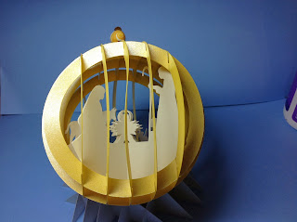

Christmas Nativity Snow Globe

I added a nativity scene to my snow globe. You need to use the previous post's instructions for the snow globe. http://papercraftetc.blogspot.com/2013/12/paper-snow-globe-sliceform-for.html

I added some beads to the top of the snow globe with wire and threaded it through the top of the snow globe at the center.

